Agenda Item: 3/01

= application site

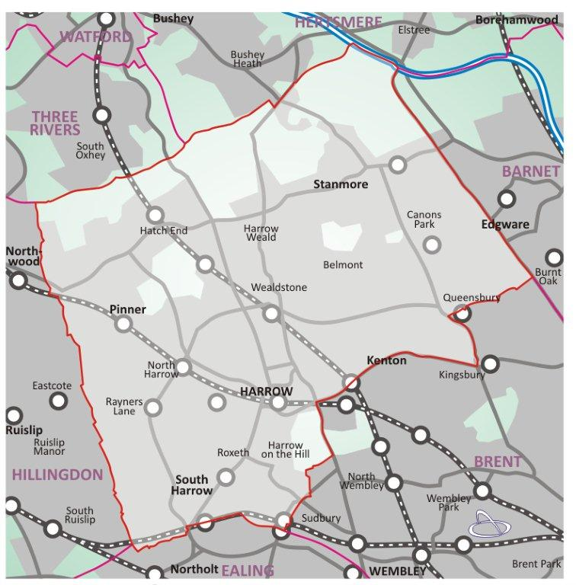

2 FALLOWFIELD, STANMORE, HA7 3DF P/4009/22

LONDON BOROUGH OF HARROW
PLANNING COMMITTEE

28th June 2023

APPLICATION NUMBER: | P/4009/22
VALID DATE: | 30TH NOVEMBER 2022
LOCATION: | 2 FALLOWFIELD, STANMORE,
WARD: | STANMORE
POSTCODE: | HA7 3DF
APPLICANT: | A GUDKA
AGENT: | RAA PLANNING
CASE OFFICER: | MUHAMMAD SALEEM
EXPIRY DATE: | 23/01/2023

PROPOSAL

Redevelopment to provide three storey building comprising of six self contained flats (4 x 3 bed and 2 x 2 bed); parking; landscaping; bin and cycle stores

RECOMMENDATION

Had this application not been appealed for non-determination, the Local Planning Authority would have recommended that this application be REFUSED. The Planning Committee is asked to:

- agree the grounds on which the local planning authority will defend the appeal as set out in this report

GROUNDS FOR DEFENDING THE PLANNING APPEAL

- The proposed redevelopment of the site, by reason of the excessive footprint of the building and its encroachment on a private rear garden area, would represent overdevelopment of the site, and would result in an over-intensive and an inappropriate form of development, at odds with the Council’s spatial strategy for growth, which directs new residential and other development to the Harrow and Wealdstone Opportunity Area, town centres and, in suburban areas, to strategic previously developed sites, and would therefore harm its implementation contrary to the National Planning Policy Framework (2021), policies CS1.A and CS1.B of the Harrow Core Strategy 2012 and adopted Supplementary Planning Document: Garden Land Development (2013).
- The proposed development, by reason of its excessive footprint, height and proximity to site boundaries, siting on higher land levels in relation to the neighbouring property to the west, overall scale, bulk and design in conjunction with the projecting front balconies, and lack of adequate setting space would introduce an overly dominant, prominent, obtrusive, cramped and incongruous building, which fails to respect the high quality, traditional character and appearance of the streetscene and the prevailing pattern of development of the wider area. The proposal thus fails to preserve or enhance the character and appearance of the adjoining conservation area as well as the general streetscene of Fallowfield. There is not a clear and convincing justification for the heritage harm, nor public benefits to outweigh it. The development is therefore contrary to the National Planning Policy Framework (2021) paragraphs 197, 199, 200, 202 and 206, Policy D3 (D(1) and (11)) and HC 1 C of The London Plan (2021), Core Policy CS1.B of the Harrow Core Strategy (2012), Policy DM1 A, DM1 B (a), (b) (c) and DM7 of the Harrow Development Management Policies Local Plan (2013) and the adopted Supplementary Planning Document: Residential Design Guide (2010) and the adopted Stanmore and Edgware Conservation Areas SPD (December 2013) including appendix 1: Little Common Conservation Area Appraisal and Management Strategy.
- The proposal, by reason of the internal floor to ceiling heights failing to meet the minimum floor to ceiling height of 2.3m for at least 75% of the Gross Internal Area of the flats, lack of defensible space to the front of the ground floor flats and inadequate provision of private amenity space for the occupiers of the ground floor flats would result in a cramped and poor standard of living accommodation for future occupiers to the detriment of the residential amenities of the potential future occupiers of the subject dwellings, contrary to the National Planning Policy Framework (2021), Policies D3 and D6 of The London Plan (2021), Paragraph C2.3 of the Housing Design Standards London Plan Guidance (2023),Policies DM1 and DM27 of the Development Management Policies Local Plan (2013) and the adopted Supplementary Planning Document: Residential Design Guide (2010).

- The proposal, by reason of the height and the siting of the building at higher land levels in relation to the adjacent properties, close proximity to site boundaries, would represent an overbearing, visually dominant and obtrusive form of development, which would result in loss of privacy and outlook, to the detriment of the residential and visual amenity of the adjacent occupiers, contrary to the National Planning Policy Framework (2021), Policy D3 of the London Plan (2021), Policy DM1 of the Harrow Development Management Policies Local Plan (2013) and the adopted Supplementary Planning Document: Residential Design Guide (2010) .

- The proposed development fails to provide adequate car parking provision for the new flats with an excessively wide new vehicular crossover to the detriment of highway safety in this locality and would also give rise to potential overspill parking in the surrounding residential roads, which would contribute to congestion and parking stress in the locality, contrary to London Plan (2021) Policies T4 T6 and T6.1 and policies DM1 and DM42 Harrow Development Management Policy (2013).

- The proposal, by reason of the site being located within an area of land liable to flooding and within 5 metres of a culverted watercourse, and the lack of provision of an acceptable drainage strategy and surface water flooding mitigation measures, has failed to demonstrate that the future occupiers of the proposed development would not be exposed to unacceptable levels of surface water flood risk within the site and adjacent to the site, contrary to the National Planning Policy Framework (2021), policies SI 12 and SI 13 of The London Plan (2021), Core Policy CS1 U of Harrow Core Strategy (2012) and Policies DM 9 and DM11 of the Harrow Development Management Polices Local Plan (2013).

- The applicant has failed to demonstrate the proposed development would not result in unacceptable impacts on the tree adjacent to the rear site boundary. The proposal is therefore contrary to the National Planning Policy Framework (2021), Policy G6 of the London Plan (2021), and Policies DM20, and DM22 of the Harrow Development Management Policies Local Plan (2013)

INFORMATION

This application is reported to Committee as in the opinion of the Chief Planning Officer, the proposals are likely to be of significant public interest. The proposal therefore does not fall within any of the provisions set out at Paragraphs 1 (a) to 1 (g) of the Scheme of delegation dated 12th December 2018.

Statutory Return Type: | Minor Dwellings
Council Interest:  Net Additional Floorspace: | n/a  549m²
GLA Community Infrastructure Levy (CIL): | £32,940
Local CIL requirement: | £88,026.66

HUMAN RIGHTS ACT

The provisions of the Human Rights Act 1998 have been taken into account in the processing of the application and the preparation of this report.

EQUALITIES

In determining this application the Council has regard to its equalities obligations including its obligations under section 149 of the Equality Act 2010.

For the purposes of this application there are no adverse equalities issues.

S17 Crime & Disorder Act

Policy D11 of The London Plan (2021) and Policy DM1 of the Development Management Polices Local Plan (2013) require all new developments to have regard to safety and the measures to reduce crime in the design of development proposal. It is considered that the development does not adversely affect crime risk. However, a condition has been recommended for evidence of certification of Secure by Design Accreditation for the development to be submitted to and approved in writing by the Local Planning Authority before any part of the development is occupied or use

- SITE DESCRIPTION

  - The application site comprises of a detached bungalow with a rear and front garden.

  - The site is accessed from Fallowfield and the site benefits from two vehicular accesses fronting Fallowfield.

  - There are a number of TPO trees adjacent to the rear boundary.

  - The properties on Fallowfield are characterised by a mix of typologies comprising single and two storey dwellings with pitched roofs and some examples of higher density dwellings including a three-storey flat roof apartment building (Broomfield House) to the corner with Stanmore Hill.

  - The architectural character is also mixed in nature, with clay roof tiles being a common feature, white rendered facades and brick facades. Most dwellings appear to have been built in the 1960s, with a number of dwellings which have been substantially altered or rebuilt to provide a more contemporary design, often with white-painted render finishes to facades.

  - The site directly borders the Little Common Conservation Area, which lies immediately to the north and east of site. It is also in the setting of the grade II listed Rookery including its stables which was listed in 1951.

  - It is also in the setting of the locally listed park and garden of Little Common, part of which includes the gardens to the Rookery.

  - The site has a PTAL rating 1b.

- PROPOSAL

  - The application proposes 6 flats (2x2bed and 4x3bed) within a three storey contemporary designed Art Deco style building with a flat roof.

  - The ground floor flats would have access to private gardens and the front of the site would feature soft and hard landscaping with the provision of 4 car parking spaces along with cycle and waste storage situated to the western side of the forecourt fronting Fallowfield.

  - The proposed building would have projecting balconies to the western side elevation and rear elevation.

  - The proposal would have a paved walkway leading to the front communal access door and defensible planting along the front windows of the building. The proposed units would be accessed from an internal communal hallway.

2.5 The site boundaries would have an element of soft landscaping. The flat roof would have a green roof.

2.6 The proposed building would be rendered and painted white with large Crittal style windows. The architecture of the proposal is Art Deco in appearance,

2.7 The proposal would provide two vehicular accesses fronting Fallowfield which are wider than the existing vehicular accesses.

- RELEVANT PLANNING HISTORY

N/A

- CONSULTATION

  - A total of 3 consultation letters were sent to neighbouring properties regarding this application on 30th November 2022.

  - Application was advertised as Affecting the Setting of a Conservation Area on 8th December 2022.

4.3 A total of 22 objections from neighbouring residents have been submitted. It is instructive to note that the summary of the responses received and which is set out below (with officer comments in Italics).

Summary of Comments on original consultation
Character and Appearance:

Fallowfield consists of detached houses that have been individually designed and hold a unique character. A three storey block of flats will disrupt the character of the road consisting of only houses.

There are no Art Deco elements on any immediate surroundings as suggested by the applicant.

The proposal would diminish the neighbourhood not just due to being bulky and out of scale but also aggravated by the poor quality of design.

Objection raised based on the height and scale of the building which would alter the character of the street beyond recognition where the street is made up of single dwellings.

The proposal is unsympathetic especially to the conservation area.

Officer Response:
These comments have been addressed within the report.

Residential Amenity:

The proposal with balconies on the flats will definitely compromise the privacy of the neighbours given its siting between two residential houses and towering over them. Based on height and proximity of the proposed building to neighbouring properties it would have a harmful impact. This is made even worse due to its higher elevation.

The proposed development by reason of its excessive bulk and scale and its relationship to neighbouring properties would result in an inappropriate and visually obtrusive form of development which would have an obtrusive, overbearing visual impact when viewed from neighbouring properties. The proposal would also result in loss of light of neighbouring garden.

The proposal pays lack of respect to adjacent green belt.

Highways

The proposal shows a blatant disregard for any parking provisions. The narrow road with cars often parked on both sides which makes access for larger vehicles difficult especially due to the large block of flats at the top of the road with parking outside neighbouring houses. Adding more vehicles would make it very difficult and cause bottle neck jams. This will be a hazard for fire engines, ambulances and refuse vehicles.

Also parking for visitors will be difficult and inevitably lead to the road being congested.

Drainage

There is a strict no build in place regarding the culvert. No. 2 culvert was hit during piling some twenty years ago and flooded the neighbour house and rear garden including other neighbours.

Officer Response:

The objections raised above have been noted and addressed in the relevant assessment section below.

4.4 Statutory and Non-Statutory Consultation

4.5 The following consultations have been undertaken and a summary of the consultation responses received are set out below.

Consultee and Summary of Comments

Conservation Area Officer

Objection raised

The proposal would harm the character and appearance of the conservation area and the special interest of the Rookery via impact on its setting due to:

- The bulk, height and scale of the proposed replacement building at 3 stories and covering much of the plot (ie width and depth) and its grand out of keeping Art Deco design would ensure it would be a very prominent building in views into and out of the surrounding heritage assets and block/remove characteristic surrounding openness and greenery. This would harm the special character of the heritage assets which relates to the high quality traditional design of buildings within it and the surrounding open, green character which ensures views towards these qualities are not disrupted or blocked. It would stand out in the context of the similar surrounding low scale suburban development which presently similarly preserves the heritage assets by not being dominant in the immediate setting.

- Insufficient information – there is insufficient information to fully assess the level of harm that would be caused by the proposal since no marked up key views towards or out of the conservation area, locally listed park and garden or listed Rookery have been provided.

- No justification – there is not clear and convincing justification, nor public benefits to outweigh the harm despite the requirement under the NPPF for both under paragraphs 200 and 202 respectively. This is despite the requirement under the NPPF for great weight to be given to the conservation under paragraph 199.

- The heritage statement and Design and Access statement present some arguments to justify the proposal but these are not accepted:

- They note that the flats may be visible between the trees but that the trees will largely screen this proposal. However, appeal decisions have held that tree screening cannot be taken as a permanent feature as this may die back for whatever reason.
- They note that ‘the new building will contribute to a transitional change from the more historic setting to one which is modern but reflective of high-quality architectural design, which includes Art Deco buildings’ but it is important that the benefits the setting currently provide to enhancing the special interest of the listed building and character and appearance of the conservation area (ie surrounding openness and greenery) are maintained with this proposal. Any harm needs justification under policy.
- They note that this would be similar to Broomfield flats on the border with the Conservation Area but the CAAMS notes that these were removed from the Conservation Area boundary and that any: ‘In the event of their redevelopment, the impact of proposals on the setting of the CA would be a material consideration and would allow for the character and appearance of the CA to be taken into account’.

LBH Highways

Objection raised based on level of on site parking provision provided for 6 flats, there are concerns of overspill on street car parking. The Widening of the crossover is not supported given its width exceeding 4.5m. The cycle parking provision is not considered acceptable given the two tier cycle racks.

LBH Urban Design Officer
There are positive elements to the external façade design and architecture of the proposed building with support for a faithfully reproduced Art Deco frontage. The large projecting balconies compromise this positive element and mean that the overall design is not supported. The balconies result in visual clutter.

A clear design rationale and detail of the design development to this point is not presented. Full testing of massing impacts to neighbours is required and insufficient detail has been provided to assess massing impacts fully.

The development footprint to the northern boundary causes overbearing to the property and rear garden to the north of site. In the absence of massing study there is concern regarding a three storey building. The proposal would result in loss of privacy and actual and perceived overlooking due to its projecting balconies and poorly resolved architectural design. Projecting balconies are not supported.

There is a lack of landscaping strategy and the ground floor garden areas identified as private amenity are practically unusable.

There is no defensible space to the front of the ground floor units with the bedrooms adjacent to the communal entrance.

The proposed green roof is supported as is the retention of the mature sweet chestnut tree.

LBH Drainage

The proposed development is over the existing watercourse and the applicant requires our Land Drainage consent to build within 5m. Also, there is no drainage strategy submitted for a new development. The culvert was damaged 20 years ago and resulted in flooding and we have Land Drainage Bylaw 10 to prevent such incidents.

We raise our objection for the proposals, please request further details in line with the attached.

Tree Officer

The proposal is recommended for refusal on the basis of excessive shading and dominance of the amenity area, owing to the Oak at the rear. The Oak's close proximity to the proposed development would result in significant post-development pressure caused by the Oak's dominance of the relatively small amenity space. This would be detrimental to the Oak's health and appearance in the long terms.

5.0 POLICIES

5.1 Section 38(6) of the Planning and Compulsory Purchase Act 2004 requires that:

‘If regard is to be had to the Development Plan for the purpose of any determination to be made under the Planning Acts, the determination must be made in accordance with the Plan unless material considerations indicate otherwise.’

5.2 The Government has issued the National Planning Policy Framework [NPPF 2021] sets out the Government’s planning policies for England and how these should be applied, and is a material consideration in the determination of this application.

5.3 In this instance, the Development Plan comprises The London Plan 2021 [LP] and the Local Development Framework [LDF]. The LDF comprises The Harrow Core Strategy 2012 [CS], Harrow and Wealdstone Area Action Plan 2013 [AAP], the Development Management Policies Local Plan 2013 [DMP], the Site Allocations Local Plan [SALP] 2013 and Harrow Local Area Map 2013 [LAP].

6.0 ASSESSMENT

6.1 The main issues are:

  - Principle of the Development
  - Design, Character and Appearance of the Area
  - Residential Amenity
  - Transport and Parking
  - Flood Risk and Drainage
  - Accessibility
  - Biodiversity and Sustainability
  - Fire Safety

6.2 Principle of Development

6.2.1 The relevant policies are:

- National Planning Policy Framework (2021)
- The London Plan (2021): G2, H1
- Harrow Core Strategy (2012): CS1A, CS1B
- Harrow Development Management Policies (2013): DM24
- Harrow Garden Land Development SPD (2013)

6.2.2 Harrow’s Core Strategy establishes a clear vision for the management of growth in the Borough over the Local Plan period (to 2026) and a framework for development in each district of the Borough. Policy CS1(A) directs growth to the Harrow and Wealdstone Opportunity Area and throughout the rest of the borough, within town centres and strategic, previously developed sites.

6.2.3 Policy CS1.B of the Core Strategy resists development on garden sites, recognising the propensity for such proposals to lead to unmanaged, incremental growth that undermines the spatial strategy. It also resists proposals that would harm the character of suburban areas.

6.2.4 Furthermore, the regional policy context (policy H1 of The London Plan) requires boroughs to optimise the potential for housing delivery on all suitable and available brownfield sites with particular focus on sites with existing access levels (PTALs) 3-6, which are located within 800m distance of a station, and redevelopment of car parks and low-density retail parks and supermarkets as a source of capacity.

6.2.5 The application site is situated on a residential plot and the surrounding area is characterised by low density residential single family dwellinghouses. Having regard to The London Plan (2021) policies (H1,H2 and H9) and the Council’s policies and guidelines it is considered that the proposal could provide an increase in smaller housing within the Borough.

Green Belt

6.2.6 The rear boundary of the site abuts the green belt and the site itself is not within the green belt, therefore the green belt policies in relation to its openness and the proportionate level of development would not be applicable in this case. It is considered that there would not be detrimental harm in this regard.

Garden Land Development

6.2.7 The Harrow’s Garden Land SPD provides supplementary guidance and was developed to secure the proper interpretation of the policy and to ensure that it is effective in preventing new residential development on garden land. It seeks to clarify, for the benefit of applicants and decision makers, how the Council intends the local presumption against garden development to be applied. This SPD does not introduce new policies or requirements but rather is intended to assist the interpretation and application of an existing local policy. The SPD does not form a part of the development plan but they are a material consideration, where their content is relevant, in the determination of planning applications.

6.2.8 With regards to the definition of what constitutes ‘garden land’ development, the Council has developed Supplementary Planning Document (SPD): Garden Land development, which was subject to public consultation and adopted on 11 April 2013.

6.2.9 Paragraph 3.1 of the Garden Land Development SPD (2013) provides definition of what is garden land development:

a. gardens of houses;
b. gardens of properties converted to flats and purpose-built maisonettes;
c. communal gardens to blocks of flats;
d. communal or 'open plan' garden areas serving multiple dwellings;
e. any land that formed part of a garden but which has been legally and/or physically severed from the donor property(ies); and
f. land functionally related to a residential garden (or gardens) and used solely to provide residential amenity but not forming the curtilage of the dwellinghouse.

6.2.10 However, paragraph 3.6 of the SPD recognises that proposals for the redevelopment of an existing dwelling or group of dwellings should take into account their original footprint as well as their appropriate enlargement potential. Paragraph 3.7 clarifies this further by stating “the Council will allow any enlargement in footprint that is equivalent to whichever is the larger of either:

  - the footprint of any permitted extensions (excluding outbuildings) that could be exercised for the dwelling (s); or
  - the footprint of an extension (excluding outbuildings) that would be consistent with Harrow’s adopted Residential Design Guide SPD.

6.2.11 The existing dwellinghouse currently has permitted development rights, as there are no designations or historic conditions restricting the existing dwelling being extended under Schedule 2, Part 1 of the GPDO. Given the size of the existing footprint within the site in relation to the boundaries, Officers consider it more appropriate to understand the allowable additions within Schedule 2, Part 1, Class A of the GPDO, as this would create the larger footprint in comparison to the SPD.

6.2.12 With the above considered, under Class A, the subject property could extend to a footprint to the rear and western side of approximately 120sqm (which is the 50 per cent allowance of the total undeveloped side and rear areas measuring approximately 369sqm). The existing house measures 157sqm therefore the total permitted development fallback position would result in a total built area coverage of 187sqm with a single storey side and rear extension which is limited to half the width of the original house.

6.2.13 On this basis, including the existing footprint of the dwellinghouse, any replacement units would need to have a maximum combined ground floor footprint of approximately 187sqm in order to accord with paragraph 3.6 of the adopted Garden Land SPD.

6.2.14 The proposed building would result in a development with a footprint of 221m², as such the increase in footprint resulting from the proposal would be greater than the original footprint of the subject dwellinghouse and the footprint of an extension (excluding outbuildings) that would be consistent with Harrow’s adopted Residential Design Guide SPD. Therefore, the proposed development does not fall within the exception to garden land development set out in policies 3.6 and 3.7 of the Garden Land Development SPD and would therefore constitute garden land development.

6.2.15 Based on the above planning policies and guidance, the proposal for the new residential units on a private residential garden would constitute sporadic, incremental development of garden land and would be contrary to these policies of the Harrow Core Strategy. The proposal is therefore contrary to the development plan for Harrow and there are no other material considerations that point to a decision other than in accordance with these policies.

6.3 Design, Character and Appearance of the Area

6.3.1 The relevant policies are:

- National Planning Policy Framework (2021)
- The London Plan (2021): D1, D3.D (1 and 11)
- Harrow Core Strategy (2012): CS1,
- Harrow Development Management Policies (2013): DM1, DM7, DM22

6.3.2 Policy HC1 of The London Plan (2021) requires development proposals which affect heritage assets and their settings, to conserve their significance by being sympathetic to the assets' significance and appreciation within their surroundings. The supporting text recognises that many heritage assets make a significant contribution to local character which should be sustained and enhanced.

6.3.3 Core Policy CS1.B specifies that ‘All development shall respond positively to the local and historic context in terms of design, siting, density and spacing, reinforce the positive attributes of local distinctiveness whilst promoting innovative design and/or enhancing areas of poor design; extensions should respect their host building.’

6.3.4 Policy DM1 of the DMP states that ‘’all development proposals must achieve a high standard of design and layout. Proposals which fail to achieve a high standard of design and layout, or which are detrimental to local character and appearance, will be resisted”.

6.3.5 Policy DM7.B of the DMP states that the impact of proposals affecting heritage assets will be assessed having regard to.. amongst other things (b) relevant issues of design, appearance and character including proportion, scale, height, massing, bulk, alignment, materials etc.

Siting, Scale and Bulk

6.3.6 Policy DM1 of the DMP reinforces the principles set out under The London Plan (2021) Policy D1 and D3 which seeks a high standard of design and layout in all development proposals. It goes on to state, amongst other things, that developments should contribute to the creation of a positive identity through the quality of building layout and design, should be designed to complement their surroundings and should have a satisfactory relationship with adjoining buildings and spaces. The policy highlights that buildings and structures should be of a proportion and scale that appropriately defines the public realm.

6.3.7 Paragraph 4.4 of the adopted Residential Design Guide SPD (2010) notes that the pattern of development in residential areas within Harrow is characterised by houses set back from the road with front gardens, gaps between the buildings/on corner plots and rear gardens of greater or lesser depth.

6.3.8 This part of the Fallowfield streetscene is characterised by detached dwellinghouses some of which have extended to the side or rear with large front gardens and generous distances between dwellings. There is a mix of typologies along Fallowfield with single and two storey pitch roofed houses. The only flatted historic development is the flat roofed three storey building (Broomfield House) to the corner with Stanmore Hill. The architectural character is also mixed in nature with clay roof tiles being a common feature with render and brick facades. Most dwellings appear to have been built in the 1960s.

6.3.9 The proposal involves demolition of the existing bungalow and its replacement with a three storey flatted building. The existing house is not considered to have any significant architectural merit and its demolition is considered acceptable.

6.3.10 The proposed three storey building would cover a significant portion of the plot with the building being within close proximity to the side and rear boundaries of the site. The proposed building would have a width in excess of 20m where properties generally measure a width of 15m. The proposed building footprint is overly close to the northern (rear) boundary line with three corners of the building effectively meeting the boundary line and the building fails to provide any off set from these boundaries to allow for maintenance, circulation which would also help to reduce its dominance when viewed from neighbouring properties.

6.3.11 The site topography rises steeply in an eastward direction following the route of Fallowfield. This would result in the massing of the building being more visible from the west of the site. Additionally the location of the building footprint in such close proximity to the rear and side boundaries without any screening or buffer provided would result in an overbearing and visually dominant building. It is also considered that the height of the building would result in views of the building from the east of Fallowfield.

6.3.12 The Council supports innovative and high quality architectural styles however the context of the site is also important and in this case the building design would appear out of keeping with its local context of modest bungalow and two storey tiled roof and brick built and rendered dwellinghouses. The proposal would result in a bulky flat roofed building which would be considered out of keeping with the general character of the immediate properties along Fallowfield. The proposed building fails to provide any meaningful articulation or setbacks within the elevations with a flat roof. In addition, the Council’s Urban Design Officer states that the large projecting balconies would not be acceptable given their dominance and would result in visual clutter which compromise the overall design of the building therefore the building design is unacceptable.

6.3.13 Whilst detailed drawings including the wider streetscene and context have not been provided by the applicant it is considered on the basis of Officers assessment of the site and its context that the proposed three storey building given its excessive plot coverage, height, massing and proximity to the side boundaries along with its siting on higher ground level than properties to the west would form a overbearing, dominant and incongruous development when viewed from the streetscene and long views taken from the east and west of Fallowfield (The impact on the setting of the conservation area and heritage assets is discussed further below in the relevant sections of this report).

Site Layout and Landscaping

6.3.14 The proposal would maintain a forecourt with soft landscaping and parking provision with the introduction of new extended vehicular accesses replacing the existing two vehicular access fronting Fallowfield. The existing house features extensive hard surfacing to the front of the site and the introduction of soft landscaping would be considered an improvement. The proposal would provide designated paved walkways to the entrance of the building with hedges and planting in front of the ground floor windows which provide appropriate defensible space between the communal pathway and parking areas. The proposed primary access route proposed would be capable of support by officers, subject to further detailed design secured via condition. The intention of a high-quality hard surface materials to reinforce the pedestrian priority of the access is acknowledged.

6.3.15 The proposal would also provide soft landscaping to the rear and side of the building. The proposal would plant two small trees and maintain the large Chestnut tree to the front of the property. The proposal is considered acceptable in this regard and would comply with Policy DM22.

Impact on Conservation Area and Heritage Assets

6.3.16 This proposal is sited in the immediate setting of (on the boundary of) the Little Common Conservation Area which lies to the north and east of the site. The special character and appearance of this conservation area is outlined in the Little Common Conservation Area Appraisal and Management Strategy which states:

‘Little Common CA derives much of its special character from its particular mix of high quality, period properties, a high proportion of which are statutorily and locally listed. There are some very large listed buildings set within extensive grounds, such as Stanmore Hall and Springbok House, as well as smaller scale houses built as accommodation for servants who worked there, and a Georgian former brewery which once brought an industrial element to the area. There is very high quality public and private open spaces and greenery, which lends a special soft, informal and, in some places, semi-rural ambience. The trees and open spaces provided by Stanmore Common and the picturesque ponds, surround and interact with attractive building groups in Little Common, imparting much of the special landscape and Conservation Area qualities. Tall walls marking the boundary of historic estates form another overriding attribute, as does the use of high quality traditional materials and the predominantly single family dwelling house use of the buildings which imparts a low intensity character. The interesting histories attached to many of the buildings is significant. Similarly, adding to the area’s importance is the range of key views towards landmark buildings, the architectural qualities and across open greenery, sometimes towards London, and the density of development which ranges from low to medium depending on location. It is the delicate balance of the above factors that achieves the area's special character that is both distinctive and attractive’.

‘Green spaces and ecology form an overriding and essential part of the special interest of the CA. In recognition of this, and helping to protect this aspect of its significance, the majority of the Little Common CA is within the Green Belt. The only areas outside of this designation are on the east side of Stanmore Hill around Aylmer Drive and Fallowfield. Important greenery includes public and private soft landscaping, grass areas, trees and planting. Some (but not all) key examples are highlighted within this section’

‘The assets of the conservation area derive from a combination of factors including:

- The high quality of architecture, reflected in the number of statutorily, locally listed and positive unlisted buildings.
- The attractive and green open spaces which not only surround the housing, but also are part of central core area
- The presence of bodies of water within the central area.
- The diversity, between the different areas within the Conservation Area, of buildings, density of development and size of houses.
- The number of mature trees both in private gardens and public spaces’.

‘The high quality of the often historic architecture and the openness of the Conservation Area are two of its key characteristics and it is important that these are maintained. This means the area is just as sensitive to minor residential development as larger schemes. The importance of the openness particularly means the possibility for new development and infilling or substantial extensions is limited. However, the area's desirability means high pressure for extensions/alterations and new build. This has caused occasional inappropriate developments involving intrusive, scale, bulk or design in the past’.

6.3.17 The site is within the setting of the grade II listed Rookery including its stables which was listed in 1951. The list entry for identification purposes states: ‘Early C18, pink brick. Two-storeys. Nine windows. Tile roof, with eaves cornice. Good pedimented porch on the south. Good stable range on north end is early C18 with white weatherboarded clock tower and cupola.

6.3.18 The site is also in the setting of the locally listed park and garden of Little Common, part of which includes the gardens to the Rookery. The special interest of this heritage asset is outlined by the enclosed local list entry.

6.3.19 As mentioned earlier in this report, the Art Deco design of the proposed development is considered to result in a boxy and prominent three storey building which would be out of keeping with the immediate character of the surrounding modest single and two storey residential properties. The proposed building would be within views into and out of the surrounding heritage assets impacting its openness and green character. As a result the proposal would harm the special character of the heritage assets which relates to the high quality traditional design of buildings within the conservation area and the surrounding open, green character which ensures views towards these qualities are not disrupted or blocked.

6.3.20 The proposed building given its overall design, height and boxy shape with large projecting balconies would be highly prominent and overbearing within the streetscene and is considered out of character in the context of the similar surrounding low scale suburban houses which helps preserve the heritage assets by not being dominant in the immediate setting. The Council’s Conservation Area Officer raise objections based on the impact on the setting of the conservation area and the listed garden and building and also states that further details would be necessary to assess the full level of harm that would be caused by the proposal with mark up of key views towards or out of the conservation area and listed park, garden or listed Rookery.

6.3.21 The application sets out within the Heritage Statement that the Art Deco building would contribute to a transitional change from the more historic setting to one which is modern but reflective of high quality architectural design. Officers consider that it is important that the benefits that the setting currently provides to enhancing the special interest of the heritage assets is preserved. The existing site is low scale, verdant and open in character which helps to preserve the setting of the conservation area. In contrast the proposed design and scale of the development would harm this setting. It is recognised that the conservation officer has concerns about impacts on the setting of the listed building and park and garden of the Rookery at the rear, upon considering this relationship, the view is that on balance the proposal would have limited harm due to the siting of the premises, some distance from the actual building. As well as this, there is a well-established belt of thick trees and vegetation along the boundary that screens the setting, therefore on balance this harm would not arise.

6.3.22 The application fails to provide any clear and convincing justification for the heritage harm and public benefits to outweigh it and the proposal is considered contrary to the requirements of Paragraph 200 and 202 of the NPPF.

6.3.23 In summary, the proposed three storey building given its extensive plot coverage and proximity to the side and rear boundaries, height, scale and overall design would have a harmful impact on the setting of the conservation area in terms of character and appearance of the adjacent conservation area and would be considered overbearing and obtrusive resulting in a harmful impact on the setting of the listed building and its garden. As such, the proposal would be contrary to policies outlined above.

Materiality

6.3.24 The proposed building would have a white rendered finish and properties including no. 3 Fallowfield benefit from a white painted render finish. The proposed finish would not be considered out of keeping in this regard. However the Crittal style black curved windows in relation to the Art Deco style of the building would be out of keeping with the character of the immediate area.

Waste and Cycle Storage

6.3.25 Policy DM45 of the Development Management Policies Local Plan states that ‘all proposals will be required to make on-site provision for general waste, the separation of recyclable materials and the collection of organic material for composting’. In terms of character and appearance, this policy requires refuse storage bins to ‘be located and screened to avoid nuisance to occupiers and adverse visual impact’. It is considered that the location of the refuse storage adjacent to the western site boundary to the front of the property would be unacceptable given its highly visible location.

6.3.26 The cycle storage situated to the front of the site would also be a dominant feature and should be located to the side or rear of the property with access from the side or a communal internal hallway to the rear of the site to provide a convenient and accessible route to the cycle storage.

6.4 Residential Amenity

6.4.1 The relevant policies are:

- National Planning Policy Framework (2021)
- The London Plan (2020): D5, D6
- Harrow Core Strategy (2012): CS1
- Harrow Development Management Policies (2013): DM1, DM27
- Mayor’s Housing SPG (2016)
- Housing Design Standards LPG (2023)

Impact on Amenities of Neighbouring Occupiers

Overbearing Impact

6.4.2 The proposed building given its height, siting with its close proximity to the side boundaries with a separation distance of approximately 3m from the shared side boundary with no. 3 along with its overall bulk and scale on higher ground level in comparison to no. 3 would be considered dominant and overbearing when viewed from the neighbouring property no. 3. Whilst the ground level slopes upwards to the east of Fallowfield and the adjacent property at no. 1 is on higher ground level it is considered that the height of the proposed building and proximity to the shared boundary with no. 1 would have a harmful impact on this property in terms of loss of outlook and an increased sense of enclosure.

Loss of privacy and overlooking

6.4.3 To the west of the application site is the detached property at no. 3 Fallowfield situated on lower ground level than the application site (the land level drops down to 2.82m when measured from the adjacent land level of the application site). The eastern shared boundary wall forms a high level retaining wall between these two properties. The proposed building would feature a side private garden for the ground floor flat (Flat 1) and given the lack of boundary treatment details the use of this private garden would allow views of the neighbouring garden at no. 3 and potentially result in the loss of privacy and overlooking of the garden of no. 3 which is considered unacceptable.

6.4.4 The proposal also features projecting balconies to the western side of the building at first, second and third floor levels. Given the projection and their depth it is considered that the proposed balconies would allow high level and clear views into the rear garden of the adjacent property at no. 3 and result in the loss of privacy and overlooking of the private garden of this property which is considered unacceptable. The proposed private rear garden for the other ground floor flat (Flat 2) would be situated to the eastern side which would be adjacent to the shared boundary with no. 1 Fallowfield. It is considered that the property at no. 1 is situated on higher ground level and the rear garden to Flat 2 would not result in any overlooking or loss of privacy of the garden of no. 1.

6.4.5 However, the proposed rear balconies at first and second floor level of the building would be situated close to the shared boundary with no. 1 and would allow views into the rear garden of no. 1 which would have a harmful impact on the amenities of this property in terms of loss of privacy and overlooking.

6.4.6 The front and rear elevation window arrangement of the proposed building would look towards the front hard and soft landscaped area and rear garden respectively and would not result in any significant harmful impact in terms of overlooking and loss of privacy of neighbouring amenities. In addition the amount of overlooking from first floor and second floor windows within the rear elevation of the proposed building is not considered to result in any significant impact given similar existing relationships between properties within the immediate area which forms the pattern of development where there is a degree of mutual overlooking of rear gardens in an urban context such as this.

Daylight and Sunlight

6.4.5 The Council has received objections from neighbours in relation to loss of light and overshadowing. The applicant has not provided a daylight and sunlight report, however Officers consider that the proposed building given its height and relationship with neighbouring properties given its siting in terms of orientation and set back from the shared side boundaries the proposal would not result in unreasonable overshadowing and loss of daylight and sunlight, in particular to the rear gardens of the properties at nos. 1 and 3. It would be considered unreasonable to warrant a refusal on this basis and the proposal complies with policy DM1 of the Harrow Development Management Polices Local Plan (2013).

Disturbance

6.4.6 It is considered that the proposed comings and goings from the site would be similar to that experienced within the site and would be expected within a location such as this. On this basis, officers are satisfied that the proposed development would not have an unduly harmful impact on the residential amenities of the adjoining occupiers in this regard, however the proximity of the balconies to the shared boundary with no 3 on the western side, and their elevated position in relation to this house would not only lead to a loss of privacy but increased disturbance which would be harmful to these resident’s amenities.

Residential Quality of Proposed Development

6.4.7 All the proposed 6 residential flats would exceed the minimum space standards and would benefit from dual aspect with appropriate internal storage spaces. The flats would benefit from acceptable levels of light and outlook and would feature the minimum quantum of private amenity space. Officers consider that the proposed flats would provide adequate living accommodation for the future occupiers and would accord with the relevant policies in this regard.

6.4.8 As mentioned, each of the units (2bed and 3bed flats) surpass the minimum GIA requirements set out the London Plan. The layout of the dwellings is considered acceptable and the outlook for each of the bedrooms appears sufficient within the units with dual aspect with the openings onto the side and rear balconies is considered acceptable in terms of outlook and adequate levels of light penetrating the units.

Floor to Ceiling Height

6.4.9 Policy D6 of The London Plan 2021 requires a floor to ceiling height of 2.5m for 75% of the Gross Internal Floor Area of each unit and the new Mayor of London Housing Design Standards London Plan Guidance (2023) provides further guidance as follows:- A minimum ceiling height of 2.5m is required for at least 75 per cent of the gross internal area (GIA) of each dwelling to enhance the spatial quality; improve daylight penetration and ventilation; and assist with cooling. Any reduction (from 2.5m) in floor-to-ceiling heights should only be for essential equipment in the ceiling voids above kitchens and bathrooms. (Page 20)
There is no justification put forward for the deviation from this requirement, leading to a poor quality of internal space standard contrary to policy D6 of the London Plan and the Housing Design Standards LPG. It is therefore considered that the floor heights are unacceptable.

Accessible Homes

6.4.10 Policy DM2 of the DMP seeks to ensure that all new housing is built to ‘Lifetime Homes’ standards.

6.4.11 Policy CS1.K of the Harrow Core Strategy requires all new dwellings to comply with the requirements of Lifetime Homes. Supplementary Planning Document Accessible Homes 2010 (SPD) outlines the necessary criteria for a ‘Lifetime Home’.

6.4.12 While the above policies require compliance with Lifetime Home Standards, in October 2015 these standards were replaced by New National Standards which require 90% of homes to meet Building regulation M4 (2) - ‘accessible and adaptable dwellings’. Accordingly, a condition of approval is required to ensure that the proposed development would meet regulation M4 (2) of the building Regulations which would secure an appropriate standard for future occupiers and make the units accessible to all. Level access would be provided to the units and if the development were recommended for approval a condition would have been recommended to ensure that the development complies with Part M of Building Regulations.

Amenity Space

6.4.13 Harrow Policy DM27 addresses amenity space and states that an appropriate form and amount of amenity space should be informed by the Mayor of London Housing Design Guide (2016) and other factors such as pattern of development, privacy of neighbouring occupiers and the quality of space proposed. Policy DM27 also states that proposals that would fail to provide appropriate amenity space will be refused.

6.4.14 The proposal would provide two rear gardens for the ground floor flats measuring 30sqm and 34sqm. The proposal would provide balconies as external private amenity space for the other flats measuring between 8sqm and 9.5sqm. Whilst the two garden areas far surpasses the minimum requirements set out in the London Plan requirement (5sqm for 1-2bed spaces in a flat and an additional 1sqm for each bedroom) it is considered that large Oak tree to the rear of the site would overshadow the amenity space for Flat 2 and would result in excessive shading and dominance which would reduce the quality of the amenity space for future occupiers. In addition, the shape of the private gardens with their depth and skewed rear boundary with the irregular shaped spaces would not provide useable or high quality amenity spaces for Flats 1 and 2. The proposal would also fail to provide amenity spaces which are in keeping with those within the immediate area.

6.4.15 The side balconies with glazed privacy screens to the western flank of the building would not be considered private amenity space given that they would be visible and overlooked by the public realm. In addition, the proposed balconies to the side and rear would allow overlooking and result in the loss of privacy for the ground floor rear gardens of Flats 1 and 2. Therefore the quality of the private amenity spaces would be unacceptable.

6.4.16 In summary, the proposal would provide poor quality accommodation for future residents of these dwellings and would provide unsatisfactory living conditions for the occupiers and this would fail to comply with the amenity aims of London Plan Policies D3, D4, D6; DMP Policies DM1 and DM27 the Mayors Housing SPG and the requirements of the Framework’.

6.5 Traffic and Parking

6.5.1 The relevant policies are:

- National Planning Policy Framework (2021)
- The London Plan (2020): T4, T5, T6, T6.1
- Harrow Core Strategy (2012): CS1
- Harrow Development Management Policies (2013): DM42, DM44, DM45

6.5.2 The site has a PTAL of 1b which means the access to public transport is poor. The nearest bus stop is on Stanmore Hill which is 110metres from the site (2minute walking distance from the site and is within 1km of Stanmore tube station and the town centre. There is a low site accessibility, the location is on a hill making it difficult for those with mobility impairments to walk and residents in these areas in Harrow tend to rely on private motor vehicles. In addition, the low bus frequency in this location is also an issue given its suburban location.

Car Parking Provision

6.5.3 The London Plan maximum parking standards would require 1.5 parking space per dwelling. A number of residents objected regarding the parking and increased impact in the surrounding area. The proposal would provide 3 parking spaces and 1 disabled parking bay within the front of the site. Given the low PTAL level the Council’s Transport Officer recommend 1 space per dwelling. The parking provision is therefore considered unacceptable and has the potential for on street parking overspill which is not supported.

6.5.4 The applicant submitted a Transport Note with a data consensus for the borough and ward in terms of car ownership and on this basis consider that there would be only an overspill of 1 on street space given the average parking provision of 4-5 spaces being provided for the number dwellings. There are no further details submitted with a parking survey in terms of level of on street parking and it would have been reasonable to warrant a refusal on this basis.

Access

6.5.5 The proposal seeks to increase and reposition the existing vehicular crossovers fronting Fallowfield. The existing crossovers measure 4.5m in width which meets the Council’s highway requirements. The proposed crossover to the east of the site would be considered acceptable in terms of its width measuring 4.55m. However the existing crossover to the west of the site measures approximately 4.5m and the proposed crossover would reposition this away from the side boundary and extend to a total width of 5.6m which is considered unacceptable in terms of highway safety given the reduction in safe refuge between the two large crossovers for highway users contrary to which policy DM42 of the Harrow DMP.

Cycle Parking Provision

6.5.6 The proposal includes a communal cycle store for up to 12 cycles within the communal hallway at ground floor level within two tier racks and two visitor cycle spaces within a store in the forecourt.. This level meets the minimum requirements of the London Plan 2021 policy T5 which requires at least two spaces per dwelling and two visitor spaces. However, the proposed cycle parking within vertical / two tier racks is unacceptable due to the lifting of the cycles involved from the top tier which is not practical for all users. As such the proposal would be contrary to the aims of Policy T5 of the London Plan (2021)If the proposed development were recommended for approval further details would have been sought to provide an acceptable cycle parking arrangement.

Waste Storage

6.5.8 The provision of a waste storage and collection of waste along with refuse bins being provided within forecourt along the western side boundary is appropriate however further details would have been requested to ensure that the proposal meets the requirement of three per dwelling as per Council guidance. Whilst there is a shortfall the details would have been secured if the application were recommended for approval with a waste management strategy being conditioned.

6.6 Flood Risk and Drainage

6.6.1 The relevant policies are:

- National Planning Policy Framework (2021)
- The London Plan (2021): SI12, SI13
- Harrow Core Strategy (2012): CS1
- Harrow Development Management Policies (2013): DM9, DM11, DM10

6.6.2 The application site is within Environment Agency (EA) flood zone 1. The applicant has not submitted a drainage strategy for the new development and the site is being built over the culverted watercourse. The Council would require a land drainage consent to build within 5m of the culverted watercourse.

6.6.3 In this case it is considered that the vulnerability and risk of surface water flooding of the site would be increased through the increase in footprint and lack of measures being outlined. It would be necessary to submit a detailed drainage strategy including details of surface water flooding management for the development. The Council’s Drainage Engineer has raised objections to the proposal on this basis and noted that the culverted watercourse was damaged 20 years ago due to piling and resulted in flooding of the neighbouring property. This has also been outlined in the objection received following neighbour consultation. In the absence of this information to safeguard the piped watercourse it is considered that the development fails to comply with policies outlined above and it would be reasonable to warrant a refusal on this basis.

6.6.4 In addition, the use of non-permeable surfacing is considered to impact upon the ability of the environment to absorb surface water, and hard surfacing of the front gardens and forecourts lead to localised surface water flooding. Hence the requirement for surface water to be contained within site and discharged to ground via the use of permeable paving or other suitable options. If the application were recommended for approval further details would have been south in regards to a cross section of permeable paving construction with full details and their maintenance plan.

6.7 Biodiversity and Sustainability

6.7.1 The relevant policies are:

- National Planning Policy Framework (2021)
- The London Plan (2021): G6
- Harrow Core Strategy (2012): CS1
- Harrow Development Management Policies (2013): DM20, DM21, DM22

6.7.2 The site represents a place where biodiversity could be enhanced and further details would have been sought if the proposal were considered acceptable with regards to the green roof, planting, bird/bat boxes to ensure the biodiversity gain to be delivered in accordance with the above policies. Officers are satisfied that this can be addressed through appropriate conditions if the development were recommended for approval in order to comply with policies DM 21 of the Harrow Development Management Polices Local Plan (2013)
.

Trees

6.7.3 The site features a large TPO Chestnut tree to the front of the site which would be safeguarded and the Council’s Tree Officer has reviewed the submitted Arboricultural Report and raised no objections to the development in this regard. To the rear of the site are two large trees which are not TPO but considered to have high visual amenity value.

6.7.4 The Council’s Tree Officer has raised objection to the development on the basis of the Oak tree which is situated to the rear of the site and its close proximity to the proposed development which would result in significant post-development pressure caused by the Oak tree dominance of the relatively small amenity space and this would also be detrimental to the health and appearance of the Oak tree in the long term. . The applicant has failed to demonstrate the proposed development would not result in unacceptable impacts on this tree. In the absence of evidence to suggest otherwise it is considered that the proposal would be contrary to policy G7 of the London Plan (2021) and Core Policy CS1 of the Harrow Core Strategy (2012), Policy DM22 of the Harrow Development Management Policies Local Plan (2013).

Sustainability

6.7.5 Policy DM 12 of the Harrow Development Management Policies Local Plan seeks to ensure that the design and layout of development proposals are sustainable. Its states that development will need to “utilise natural systems such as passive solar design and, wherever possible incorporate high performing energy retention materials”…”Proposals should make provision for natural ventilation and shading to prevent internal overheating and incorporate techniques that enhance biodiversity”. Policy DM 14 highlights that development proposals should incorporate renewable energy technology where feasible.

6.7.6 A sustainability section has been provided in the submitted planning statement which analyses sustainability issues including energy, water consumption, materials, surface water fun off, waste, pollution and transport. However details of this have not been provided in terms of this criteria, it would be expected for a scheme for 6 dwellings to incorporate such features as green roofs and or solar panels to contribute to the sustainability credentials of the scheme. The proposal provides a green roof and if the application were recommended for approval Officers would have imposed a carefully worded condition to ensure that further sustainability measures were undertaken if the application were recommended for approval.

6.8 Fire Safety

6.8.1 The relevant policies are:

- National Planning Policy Framework (2021)
- The London Plan (2021): D12 (Part A)

6.8.2 Part A of Policy D12 of The London Plan (2021), requires the demonstration of suitably positioned and unobstructed space for fire appliances and evacuation assembly points, and that developments ensure robust strategies for evacuation are in place as well as confirmation of the fire-fighting water supply. The applicants have submitted a detailed fire strategy, which details robust safety measures to ensure that the proposed building would be amenable to achieving full compliance with Part B (Fire Safety) of the Building Regulations (2010) and Building (Amendment) Regulations (2020). On this basis, it is considered that the proposed fire safety strategy would be consistent with the relevant policies and would be acceptable in this regard.

7.0 CONCLUSION

7.1 The proposed development would fail to appropriately relate to the site, local context, massing and architectural appearance and would bring forward housing provision of an unsatisfactory site layout, excessive plot coverage, height, massing and design would have a harmful impact on the character and appearance of the surrounding area including the adjacent conservation area which is to the east of the site. The proposed height, bulky design and siting within close proximity to the shared boundaries with neighbouring properties would result in a dominant and obtrusive form of development which would have a harmful impact on the amenities of these properties. The proposal fails to provide adequate internal floor to ceiling heights and private amenity spaces for the new dwellings and would result in substandard living accommodation for the future occupiers of the development.

7.2 Officers are not satisfied that the proposal would maintain an appropriate quality of residential amenity for the adjoining occupiers. The proposal would fail to enhance biodiversity on the site or provide adequate sustainable urban drainage measures to protect the existing piped watercourse within 5 metres of the site. Furthermore, the transport aspects of this proposal fail to comply with strategic and local transport policies.

7.3 For all the reasons considered above, and weighing up the development plan policies and proposals, and other material considerations including comments received in response to notification and consultation as set out above, this application would have been recommended for refusal.

APPENDIX 1: Conditions and Informatives

The National Planning Policy Framework (2021)

The London Plan (2021)
D1 London’s form, character and capacity for growth
D3 Optimising Site Capacity
D4 Delivering Good Design
D5 Inclusive Design
D6 Housing Quality and Standards
D7 Accessible Housing
D11 Safety, Security and resilience to emergency
D12 Fire Safety
H1 Increasing Housing Supply
HC1 Heritage conservation and growth
T4 Assessing and mitigating transport impacts
T5 Cycling
T6 Parking
G6 Biodiversity and access to nature
G7 Trees and Woodlands
SI 2 Minimising green house gas emission
SI 13 Flood Risk Management
SI 14 Sustainable Drainage

Harrow Core Strategy (2012)
Core Policy CS 1 A Overarching Policy Objectives
Core Policy CS1.B Local Character
Core Policy CS1.K Residential Design
Core Policy CS1.U Sustainable Flood Risk Management

Harrow Development Management Polices Local Plan (2013)
Policy DM 1 Achieving a High Standard of Development
Policy DM 2 Achieving Lifetime Neighbourhoods
Policy DM 7 Heritage Assets
Policy DM 10 On Site Water Management and Surface Water Attenuation
Policy DM 11 Protection and Enhancement of River Corridors and Watercourses
Policy DM 12 Sustainable Design and Layout
Policy DM 22 Trees and Landscaping
Policy DM 23 Streetside Greenness and Forecourt Greenery
Policy DM 24 Housing Mix
Policy DM 27 Amenity Space
Policy DM 42 Parking Standards
Policy DM 44 Servicing
Policy DM 45 Waste Management
Policy DM50 Planning Obligations

Relevant Supplementary Documents
Housing Design Standards London Plan Guidance (2023)
Mayor Of London, Housing Supplementary Planning Guidance (2016)
Supplementary Planning Document - Residential Design Guide (2010).
Supplementary Planning Document: Garden Land Development (2013) Stanmore and Edgware Conservation Areas SPD (December 2013) including appendix 1: Little Common Conservation Area Appraisal and Management Strategy.

- Refuse without Pre-App

Statement under Article 35(2) of The Town and Country Planning (Development Management Procedures) (England) Order 2015. This decision has been taken in accordance with paragraphs 39-42 of The National Planning Policy Framework. Harrow Council has a pre-application advice service and actively encourages applicants to use this service. Please note this for future reference prior to submitting any future planning applications.

- Mayoral Community Infrastructure Levy (provisional)
Please be advised that approval of this application (either by Harrow Council, or subsequently by the Planning Inspectorate if allowed on appeal following a refusal by Harrow Council) will attract a Community Infrastructure Levy (CIL) liability, which is payable upon the commencement of development. This charge is levied under s.206 of the Planning Act 2008 Harrow Council, as CIL collecting authority, has responsibility for the collection of the Mayoral CIL
The Provisional Mayoral CIL liability for the application, based on the Mayoral CIL levy rate for Harrow of £60/sqm is £32,940
The floorspace subject to CIL may also change as a result of more detailed measuring and taking into account any in-use floor space and relief grants (i.e. for example, social housing).
You are advised to visit the planningportal website where you can download the appropriate document templates.
Please complete and return the Assumption of Liability Form 1 and CIL Additional Information Form 0 .
https://ecab.planningportal.co.uk/uploads/1app/forms/form_1_assumption_of_liability.pdf
https://ecab.planningportal.co.uk/uploads/1app/forms/cil_questions.pdf
If you have a Commencement Date please also complete CIL Form 6:
https://ecab.planningportal.co.uk/uploads/1app/forms/form_6_commencement_notice.pdf

The above forms should be emailed to HarrowCIL@Harrow.gov.uk
Please note that the above forms must be completed and provided to the Council prior to the commencement of the development; failure to do this may result in surcharges and penalties.

- Harrow Community Infrastructure Levy (provisional)

Harrow has a Community Infrastructure Levy which applies Borough wide for certain developments of over 100sqm gross internal floor space.
Harrow's Charges are:
Residential (Use Class C3) - £110 per sqm;
Hotels (Use Class C1), Residential Institutions except Hospitals, (Use Class C2), Student Accommodation, Hostels and HMOs (Sui generis) - £55 per sqm;
Retail (Use Class A1), Financial & Professional Services (Use Class A2), Restaurants and Cafes (Use Class A3) Drinking Establishments (Use Class A4) Hot Food Takeaways (Use Class A5) - £100 per sqm
All other uses - Nil.
The Provisional Harrow CIL liability for the application, based on the Harrow CIL levy rate for Harrow of £110/sqm is £88,026.66

This amount includes indexation which is 323/224. The floorspace subject to CIL may also change as a result of more detailed measuring and taking into account any in-use floor space and relief grants (i.e. for example, social housing).
The CIL Liability is payable upon the commencement of development.
You are advised to visit the planningportal website where you can download the relevant CIL Forms.
Please complete and return the Assumption of Liability Form 1 and CIL Additional Information Form 0 .
https://ecab.planningportal.co.uk/uploads/1app/forms/form_1_assumption_of_liability.pdf
https://ecab.planningportal.co.uk/uploads/1app/forms/cil_questions.pdf
If you have a Commencement Date please also complete CIL Form 6:
https://ecab.planningportal.co.uk/uploads/1app/forms/form_6_commencement_notice.pdf
The above forms should be emailed to HarrowCIL@Harrow.gov.uk
Please note that the above forms must be completed and provided to the Council prior to the commencement of the development; failure to do this may result in surcharges

CHECKED

Orla Murphy  Head of Development Management  22nd June 2023 | Viv Evans  Chief Planning Officer  22nd June 2023

APPENDIX 2: SITE PHOTOGRAPHS

Front elevation fronting Fallowfield

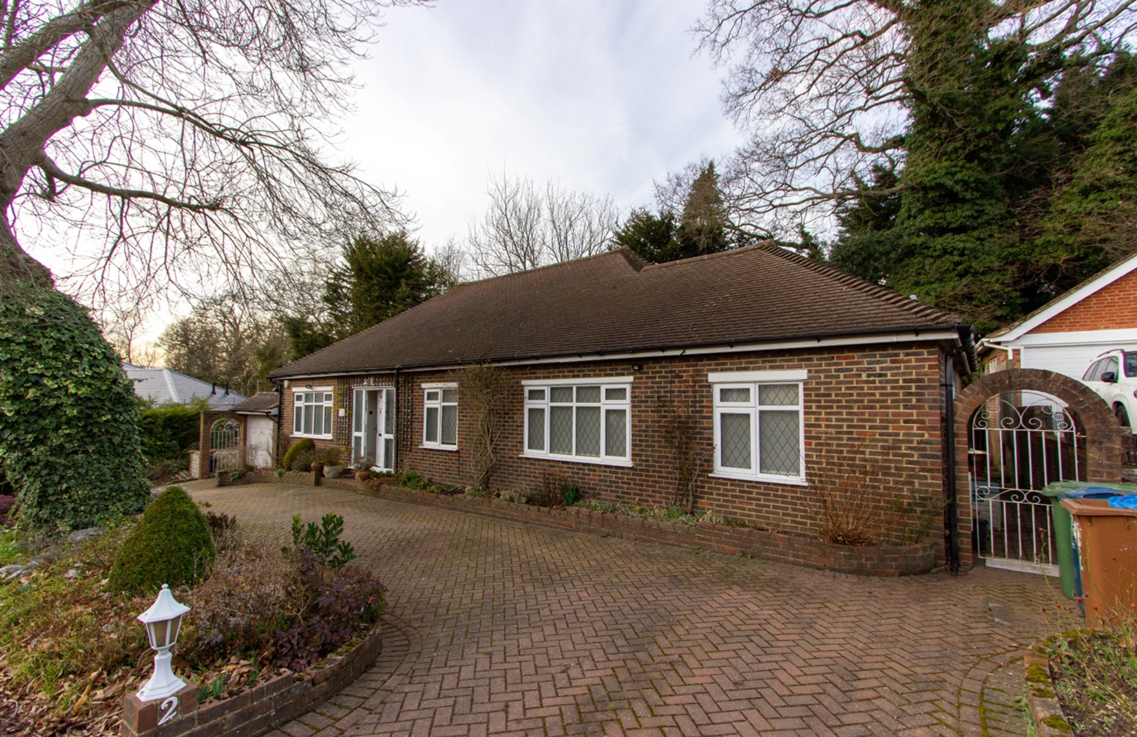
Front elevation and eastern side boundary with no. 1
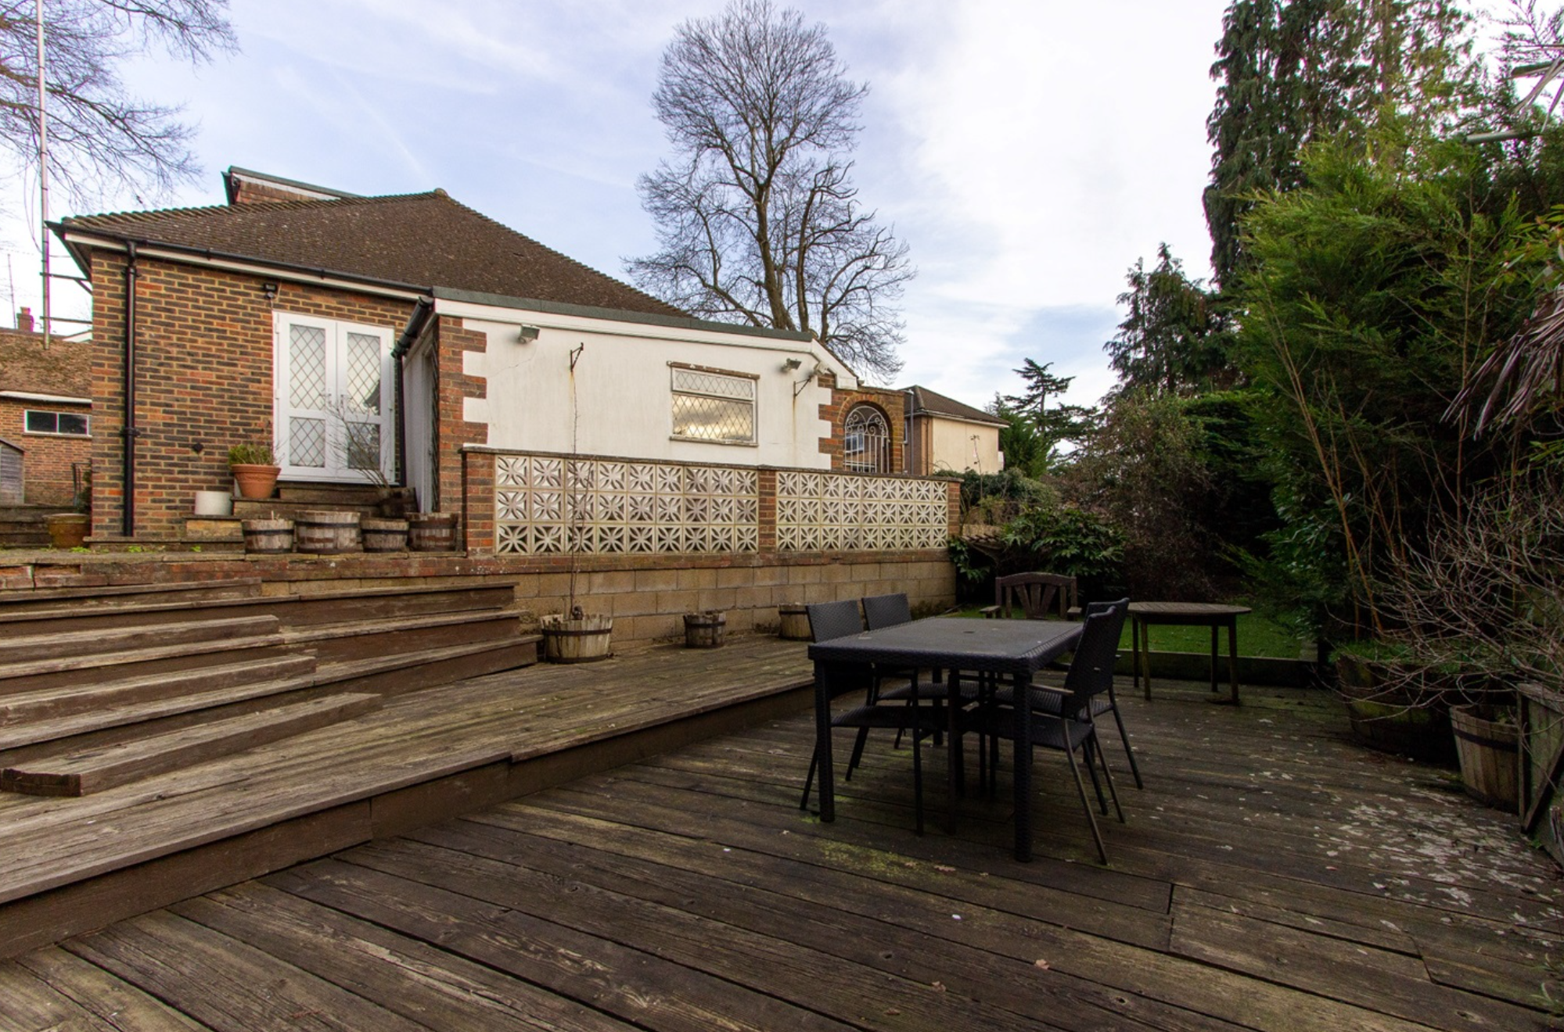
Rear Elevation and garden

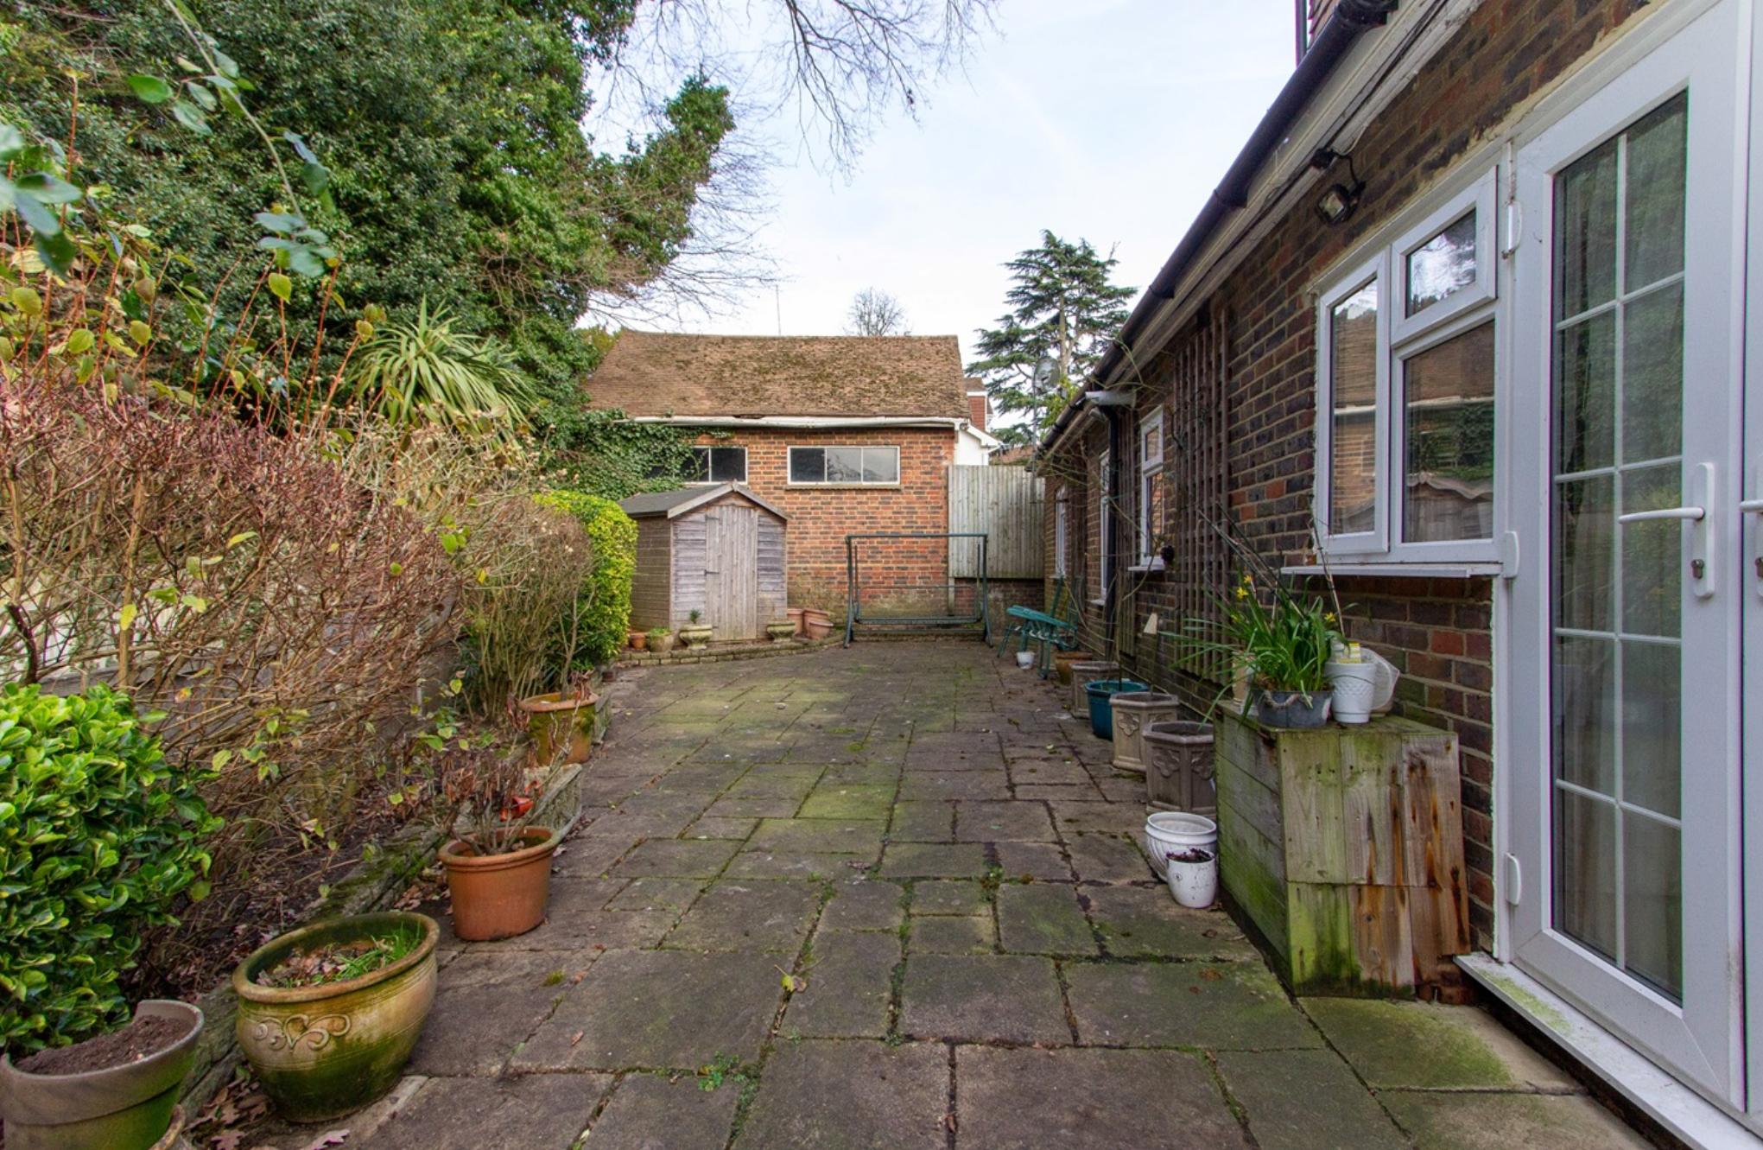
Rear - Looking towards eastern side boundary with no. 1

APPENDIX 3: FLOOR & ELEVATION PLANS

Existing Site Plan, Elevations and Floor Plans

Proposed site layout and ground floor plan

Proposed First and second floor plans

Proposed roof plan

Proposed Elevations

Proposd Front and Rear Elevations

Proposed Sections

3D Model of proposed building

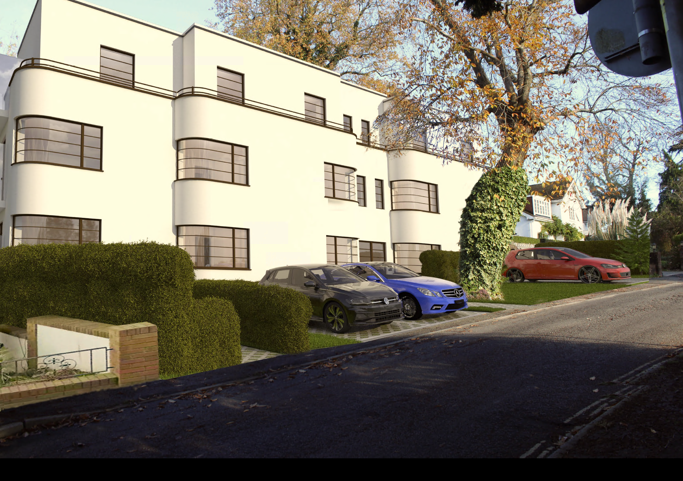
CGI image of proposed building

This page has been left intentionally blank

